【翻译参考】
Translate the following text from English into Chinese.Write your translation on ANSWER SHEET.（15 points）.
With the smell of coffee and fresh bread floating in the air,stalls bursting with colorful vegetables andtemping cheeses, and the buzz of friendly chats, farmers' markets are a feast for the senses. They also providean opportunity to talk to the people responsible for growing or raising your food, support your local economand pick up fresh seasonal produce-all at the same timt 。.
Farmers' markets are usualy weekly or monthly events, most often with outdoor stalls, which allow farmers oproducers to sell their food directly to customers. The size or reqularity of markets can vary from season toseason, depending on the area's agricultural calendar, and you're likely to find different produce on sale atdifferent times of the year.By cutting out the middleman, the farmers secure more profit for their produce.
Shoppers also benefit fronseeing exactly where -and to who- their money is going.
【参考答案】
在咖啡和新鲜面包的香气中飘动，摊位上陈列着五颜六色的蔬菜和诱人的奶酪，以 及友好聊天的喧嚣声，农贸市场是一场感官的盛宴。它们不仅提供了与种植或饲养你食 物的人交流的机会，支持当地经济，还能同时购买新鲜的季节性农产品。
农贸市场通常是每周或每月的定期活动，往往有户外摊位，使农民或生产者能够直 接向顾客销售他们的食物。市场的规模或频率可能会因季节而异，取决于该地区的农业 日历，你可能会在一年中的不同时间找到不同的农产品出售。购物者还可以从中受益， 确切地了解他们的钱去了哪里以及给了谁。
【小作文】
Directions:
Suppose you and your friend Jack will do a survey on the protection of old houses in an ancient town. You should
1）put forward a plan and
2）ask for opinion.
You should write about 100 words on ANSWER SHEET
Do not use your own name. Use “Li Ming” instead. (10 points)
【参考范文】
Dear Jack，
We are embarking on a survey about the preservation of old houses. This survey is not just a mere academic exercise; it is a heartfelt plea for the preservation of our cultural heritage.
I am writing this letter to propose a plan and ask for your opinion.
I intend to conduct a survey through an online questionnaire, which will be distributed to participants across the country. The questionnaire includes questions about，firstly, the current condition of old houses in their community, secondly the primary factors contributing to their deterioration,and thirdly measures taken by local governments to preserve old houses.
If you are so kind as to provide me some suggestions about the methodology of the survey, I will be greatly obliged. I am looking forward to doing the survey with you to guard our cultural heritage.
Your sincerely,
Li Ming
【大作文参考】
Directions:
Write an essay based on the chart below.ln your writing.you should
1 )interpret the chart,and
1) give your comments.
You should write about 150 words on the ANSWER SHEET.(15points)
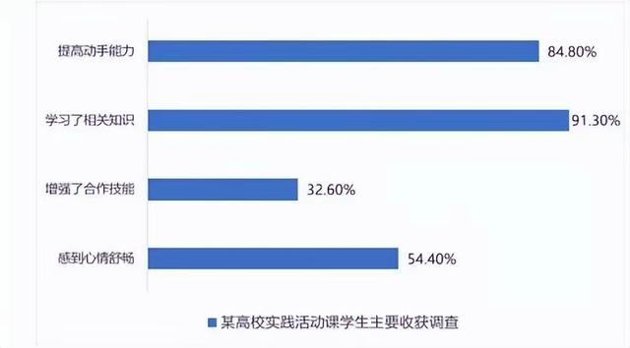

【参考范文】
The chart given above reflects a survey on the main gains of students in labor practice courses at a certain university. According to the data,improving hands-on ability takes a lion’s share, accounting for 84.80%, while that of learning relevant knowledge occupies a comparatively large proportion, taking 91.30%. The end of enhancing collaborating skills and feeling relieved
take away 32.60%, and 54.40% respectively.
Why college students are beneficial from these practical courses,especially improving their hands-on capability? There are generally several factors accounting for it. The first one is the authorities have issued a series of preferential policies to protect and promote the development of educating industry, which encourages a widespread emergence of practical courses regarding labor that can provide youngsters with more practical ability. In addition, it must be pointed out that people’s idea toward labor practice courses have undergone some radical changes in recent years. In the past, people used to pay attention to theoretical knowledge, but now they are willing to improve their hands-on ability.
The survey highlights the importance of labor practice courses in providing students with valuable real-world experience and professional skills. The results suggest that colleges should continue to invest in these programs to ensure that students are well-prepared for the job market and can make a positive contribution to society

【二、图文完整版】
